Title (Arial 14 pts., bold)

Subtitle (Arial 12 pts., bold)

Author 1 (Times New Roman, 12 pts.)  Institution, Country  author1@email | Author 2 (Times New Roman, 12 pts.)  Institution, Country  author2@email | Author 3 (Times New Roman, 12 pts.)  Institution, Country  author2@email

Abstract (Arial 12 pts., bold)
The abstract header should be formatted using the {Abstract Header} format element. The abstract text should be formatted using the template’s {Abstract} format element. Please do not provide more than 250 words.
Keywords: Please enter the keywords using lower-case letters except for proper nouns. Please separate each keyword or keyword phrase by a semicolon (e.g., “linked data; evaluation; information retrieval”). The keywords should be formatted using the {Abstract} template element.

1. Sections of Papers and Project Reports (Arial 12 pts., bold)
Major sections headings must be formatted using the {Heading 1} template element. Capitalize all words in the major heading. Text should be formatted using the {Paragraph Normal} template element.
Lorem ipsum dolor sit amet, consetetur sadipscing elitr, sed diam nonumy eirmod tempor invidunt ut labore et dolore magna aliquyam erat, sed diam voluptua. At vero eos et accusam et justo duo dolores et ea rebum. Stet clita kasd gubergren, no sea takimata sanctus est Lorem ipsum dolor sit amet. Lorem ipsum dolor sit amet, consetetur sadipscing elitr, sed diam nonumy eirmod tempor invidunt ut labore et dolore magna aliquyam erat, sed diam voluptua. At vero eos et accusam et justo duo dolores et ea rebum. Stet clita kasd gubergren, no sea takimata sanctus est Lorem ipsum dolor sit amet.
Quotations of 50 or more words must be set off as a separate text block using the {Quotation} template element.
Lorem ipsum dolor sit amet, consetetur sadipscing elitr, sed diam nonumy eirmod tempor invidunt ut labore et dolore magna aliquyam erat, sed diam voluptua. At vero eos et accusam et justo duo dolores et ea rebum. Stet clita kasd gubergren, no sea takimata sanctus est Lorem ipsum dolor sit amet.

1.1. Minor Section Heading (Arial 11 pts., bold)
Minor section headings must be formatted using the {Heading 2} template element.

1.1.1 Minor Section Heading (Arial 11 pts.)
Third-level minor headings must be formatted using the {Heading 3} template element.

2. Tables and Figures
Tables and figures/images must not extend outside the margins of the text area. Captions for tables appear above the table and captions for figures appear below. Use the {Caption Label} template for both tables and figures. Color in tables and figures should not be used.

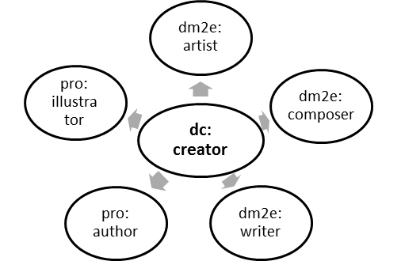

FIG. 1. Example figure. (Times New Roman, 9 pts.)

TABLE 1: Example table. (Times Roman, 9pts.)

Template Label | Formatting
Title | Arial 14 pts., Centered
Author | Times Roman 11 pts., Centered (Table)
Header Abstract | Arial 12 pts., Bold

3. Style of Citations and References
Authors should use the APA Citation Style. Use the American Psychological Association Publication Manual (5th Edition) for detailed instructions. The reference entries are formatted using the {Reference} template element:
“According to Petras (2007) and Dröge (2013, pp. 21-23)…”
“The DM2E model (Dröge, Iwanowa & Hennicke, 2014a) has been built as a specialization…”
“All data was mapped to the DM2E model version 1.1, latest revision (Dröge, Iwanowa et al., 2014b)…”

4. Page Numbering
Authors should not use the automatic page numbering provided by their word processing program.

Acknowledgements
Acknowledgements should be formatted using the {Abstract} template element.

Footnotes
Footnotes appear at the foot of the page. Do not use endnotes.

References
Alexander, Keith, Richard Cyganiak, Michael Hausenblas, and Jun Zhao. (2009). Describing Linked Datasets. On the Design and Usage of VoID, the “Vocabulary of Interlinked Datasets”. In Bizer et al. (Eds.), Proceedings of the Linked Data on the Web Workshop (LDOW2009), Madrid, Spain, April 20, 2009, CEUR Workshop Proceedings. Retrieved, May 14, 2014, from http://ceur-ws.org/Vol-538/.
Auer, Sören, Jan Demter, Michael Martin, and Jens Lehmann. (2012). LODStats – An Extensible Framework for High-Performance Dataset Analytics. In ten Teije et al. (Eds.), Knowledge Engineering and Knowledge Management. 18th International Conference, EKAW 2012, Galway City, Ireland, October 8-12, 2012, Proceedings (pp. 356-362). Berlin, Heidelberg: Springer. doi: 10.1007/978-3-642-33876-2.
Carroll, J. Carroll, Christian Bizer, Pat Hayes, and Patrick Stickler. (2005). Named Graphs. In Journal of Web Semantics, 3, 247-267.
Heath, Tom, and Christian Bizer. (2011). Linked Data: Evolving the Web into a Global Data Space. Synthesis Lectures on the Semantic Web: Theory and Technology (Vol. 1). Morgan & Claypool.

This is an example footnote.

